Marriage
Two Condition Of Marriage
1.Bride Is a Foreigner
2. Bride Isn’t a Foreigner
Bride is a Foreigner
Plz Follow The Following Steps To Complete Your Marriage Registration
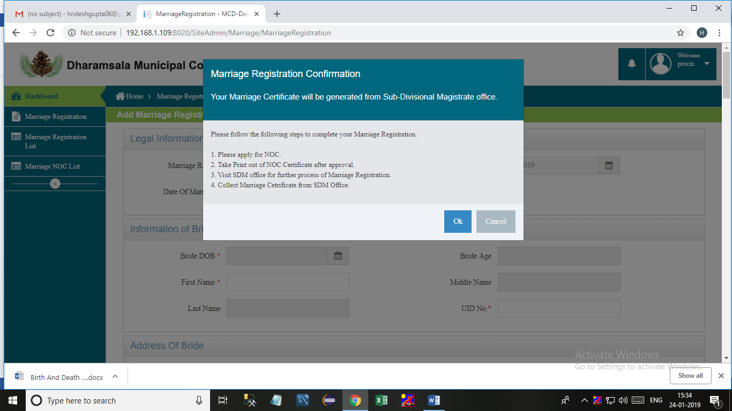
: Select Any Date
Fill All Information of Registration than click to Submit
: Payment
: Screenshot of Receipt
then go to Citizen site: NOC Generated or not
Get NOC Certificate go to SDM office (manually process) not Using System

2. Bride Isn’t a Foreigner
Bride isn’t a Foreigner
Date of Marriage between 90 day
: Select Any Date 24-01-2019
Fill All Information of Registration than click to Submit
: Payment
: Screenshot of Receipt
Approved by marriageofficer1 and marriageregistar

Date of Marriage after 90 days
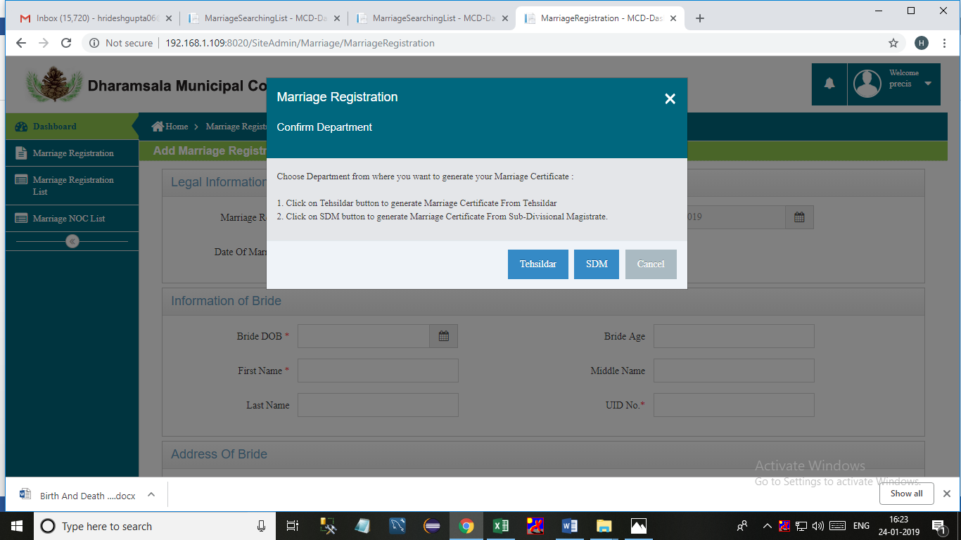
Select Any Date After 90 Days 24-10-2018
Certificate Generated by Tehsildar or SDM
Tehsildar:-
Fill some Information For Registration than click to Save And Apply For NOC
: Payment
: Screenshot of Receipt
Approved by marriageofficer1 and marriageregistar
: Registration Approved By marriageofficer1 and marriageregistar
marriageofficer1@gmail.com
admin@123
marriageregistar@gmail.com
Tehsildar will provide a unique Number, Then Visit To DMC with Unique NO. and NOC certificate
Go to Site of marriageofficer1 And Add Unique No. After that Go to citizen site and fill all information and Approved by marriageofficer1 and marriageregistar
Certificate Generated or not on Citizen site
SDM :-
: Select Any Date After 90 Days
Fill some Information of Registration than click to Submit
: Payment
: Screenshot of Receipt
Approved by marriageofficer1 and marriageregistar For NOC
Need Documents
